

**PA-44 WEIGHT & BALANCE WORKSHEET**

Completed By: _________________Date: _______________N-Number:_____________________

**FORMULAS**

* Weight × Arm = Moment
* Total Moment ÷ Total Weight = CG
* Max Ramp Weight – Zero Fuel Weight = Usable Fuel Weight
* Fuel Weight ÷ 6 = Fuel Gallons
* 100 LL (Blue) Fuel Weighs 6 lbs./gal.; Oil Weighs 7.5 lbs./gal.

**CG ENVELOPE GRAPH**

* 2 Gallons of unusable fuel and oil at full capacity are Included in Basic Empty Weight

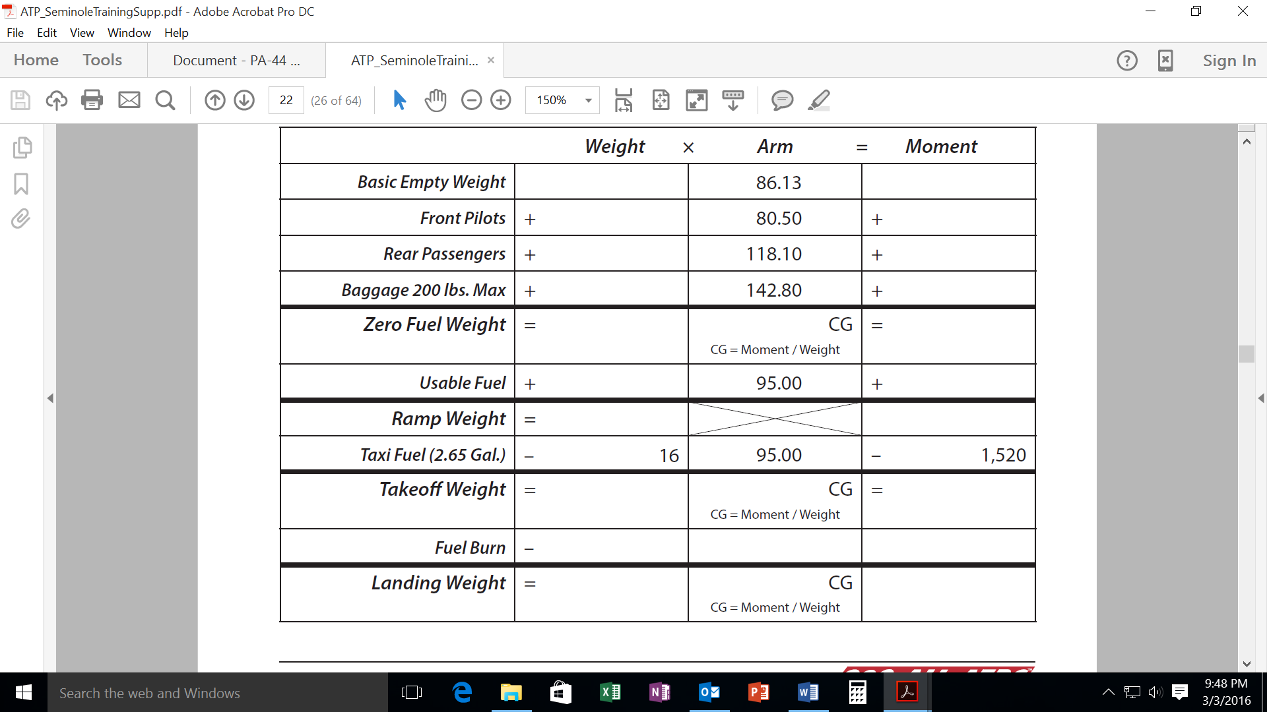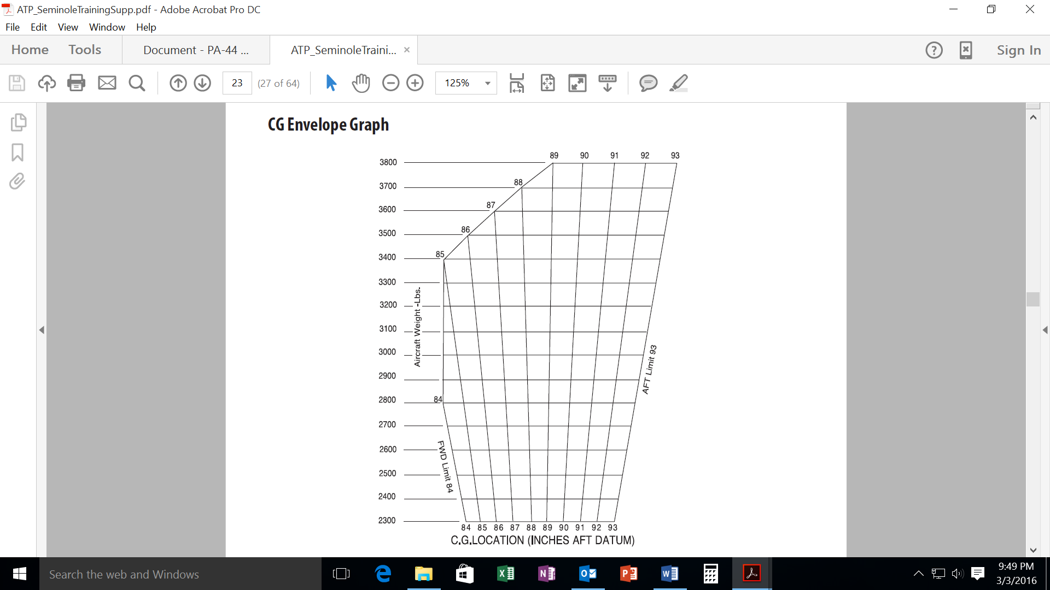

**87.1**

